**SSW 567 - Assignment 11**

**Group 5**

Ed Chang

Harmony Sullivan

**Assignment Description**

Hopefully this is an easy project.

You need to write up a report on your testing progress for the triangle program for your boss.  Uses the techniques you've learned to write up the best progress report you can.

How’s the testing going? How’s the quality of the release?

**Results**

Group 5 asserts that our triangle program is ready to ship – this is based on the analysis we performed based on the GQM methodology.

Summary of Triangle Program: This is a java (not web application) program which accepts triangle lengths and reports the type of triangle as well as whether or not it is a right-angle triangle.

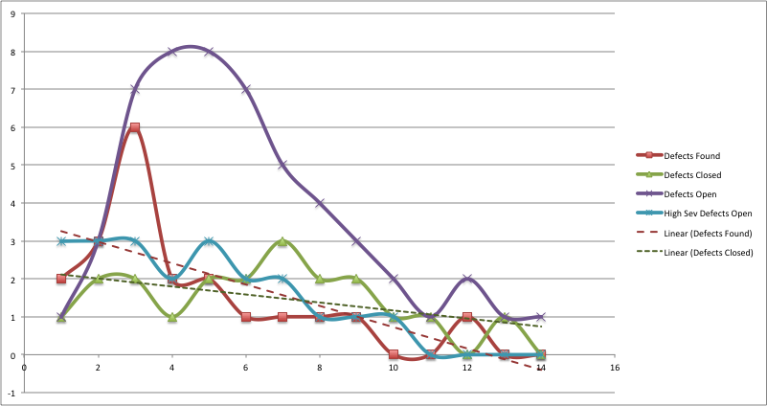Based on the chart above for the defects found and defects closed for this release of the Triangle program, the defects found (red line) have been decreasing over time. After the initial surge at the start of the program, the number of defects found has been steady over the last 9 DAYS. At the meantime, the defects that remained open (purple line) decreased slightly over the same period of time. Lastly, the number of ‘High Severity Defects’ that remained open (blue line) went to zero starting on DAY 11 and there hasn’t been any change since.

Looking at the trendlines for the defects found (dotted red line) vs. defects closed (dotted green line), we see that as an average, the team can fix a little more than 1 defect per DAY. At the same time, the trendline indicated that defects found have been declining steadily overtime. Other than the only exception that took place at DAY 12 when one defect was found; the Triangle program has been performing quite well, considering that only 1 defect remains open at this time.

As we investigate the defect discovered on DAY 12, we realized that the test team had found an escape during the previous round of testing and additional tests have been added to ensure there is proper test coverage. In addition, the development team was able to fix (close) the defect at the same DAY.

Lastly, the indication shown that testing has been stable and we are addressing the defects along the way. We have nearly closed all defects, most importantly; all high severity defects have been fixed (closed).

Based on this set of data, our assessment is that the Triangle program is ready to be released.

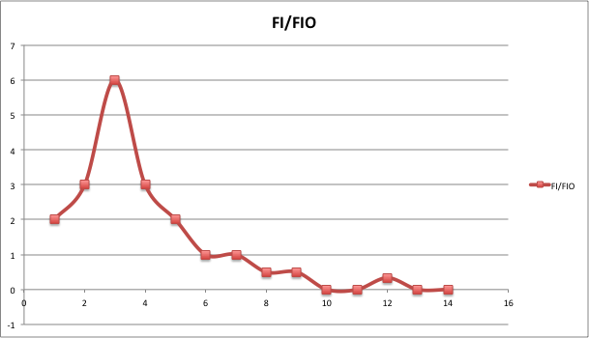Next, we look at the Failure Intensity and the related Failure Intensity Objective to normalize the defects over time. In this case, we are looking for a factor of less than 0.5 to determine if the Triangle program is ready to be released. Based on the graph above, it shows that after the initial surge of failures (as expected early on for a program), the FI/FIO factor for Triangle program was 0.5 since DAY 8 and been at or below that ever since. Once again, outside the DAY 12 when one additional defect was found, the FI/FIO factor has been well below 0.5, i.e. equal or better than what we were looking in order to determine the readiness for the release the Triangle program. Knowing that the data at times might be inaccurate that could misled us to the wrong conclusion, the factor of 2 for the FI/FIO value, i.e. less than 0.5, gives us sufficient margin to declare that the Triangle program is ready to be shipped from this perspective.

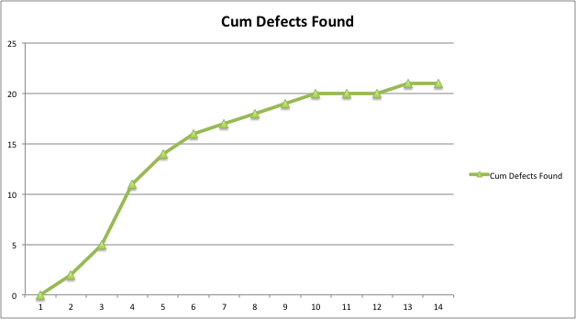

Lastly, we looked at the cumulative defects found over time. In this case, the graph above is similar to what we had expected with as a S-Curve for the defects found from the start of the Triangle program. In addition, the graph below for the defects found over time also confirm that it’s following the Rayleigh Distribution Curve as we expected for the defect arrival rate (with the exception of the one defect found on DAY 12). Based on this data, we can see that the Triangle program is now stabilized in terms of defects and the Triangle program is ready to be released.

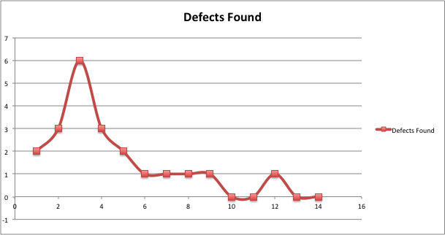

**Lessons Learned**

We derived our assessment based on the Goal, Question, and Metrics (GQM) methods. Our goal was to understand the quality of the Triangle program release. The questions we asked ourselves were to assess the open defects, reliability of the program, and the expected defect density. The metrics we reviewed were the defects opened/closed over time, failure intensity vs. failure intensity objective, and how well the Triangle program performed against the defect density prediction.

* For meaningful analysis, we needed to add defect data to complete our analysis. The data we collected from weeks 2 and 4 was not sufficient.
* Due to insufficient data available, we made up scenarios for the test cases, defects found, defects fixed, and high severity defect remained open.
* Failure intensity is derived from the defects found data that we made up.
* Regardless of the data that we made up, it’s still up to us to determine the meaning of the information available, i.e. apply personal analysis and assessment the readiness of the system based on the current state.
* A defect was discovered on DAY 12; additional tests were implemented to ensure proper test coverage was provided.

**Honor Pledge**

We pledge on our honor that we have not given or received any unauthorized assistance on this assignment/examination. We further pledge that we have not copied any material from a book, article, the Internet or any other source except where I have expressly cited the source.